Beaded Tassel Tutorial
June 15, 2016 Seed Bead, Tutorial

Tassels are trending! We are loving the beaded tassel trend and could not wait to share our beaded tassel tutorial with you!

What you will need:

- Seed Beads
- Beading Thread
- Wire
- Needle
- Bead Cap or End Caps
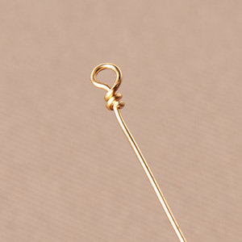
Step One: Cut 22-gauge wire and make a wire wrapped loop. Make sure to make a loop small enough so seed beads can not pass through.

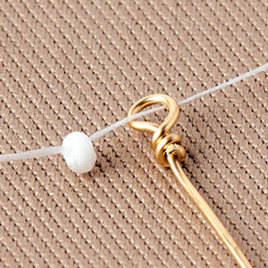
Step Two: Knot a bead to the end of the thread. Feed the thread through wire loop.

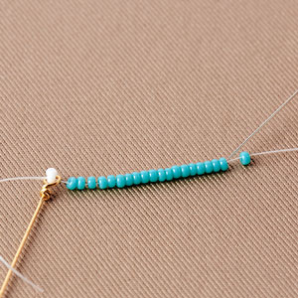
Step Three: String on your preferred amount of seed beads. (Here we are using size 11 Miyuki seed beads.)

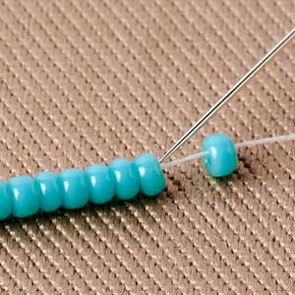
Step Four: Skip the last bead and thread the needle back though the beads.

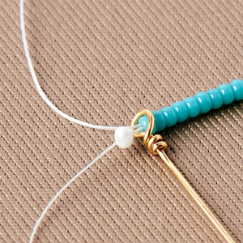
Step Five: Thread through the wire loop.

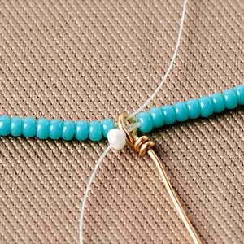
Step Six: String on beads and thread back through the beads while skipping the last bead. Then go back through the wire loop.

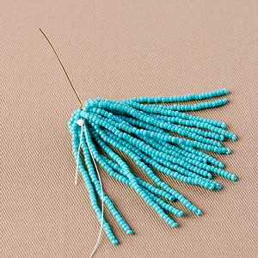
Step Seven: Repeat until you’ve reached a desired thickness. This thickness is according to how full you want your tassel to look within the bead cap or end that is being used. Tie off the ends and cut excess. You can add fast-drying glue to secure the knots.

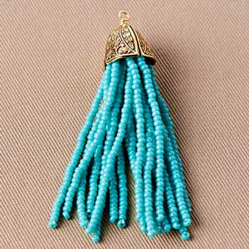
Step Eight: Add your bead cap or bead end and make a wire wrapped loop. You’ve completed your beaded tassel.

Guinevere Beaded Tassel Lariat Necklace

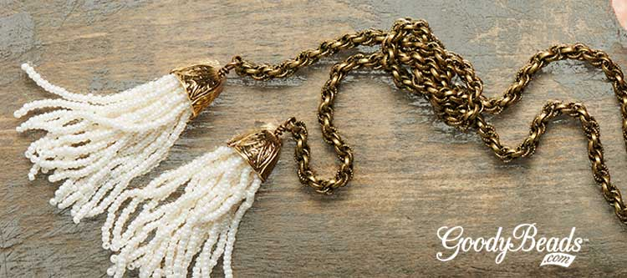
Designed by Tory Vezina
If Queen Guinevere wore a tassel necklace, this would be the necklace. With pearl seed beads and spiral rope chain, this necklace is perfect for common folk to feel like a queen!

The tassel was made with size 11 pearl seed beads and gold end caps. Make two beaded tassels. Cut some rope chain at 3-4 feet and attach each end with a brass jump ring and beaded tassel. Wear this lariat necklace loose while wrapped around once or twice. Or tie a knot 2-4 inches away from your beaded tassel.

Check out our June 2016 Beaded Tassel Trend for more inspirational jewelry!

Guinevere Beaded Tassel Lariat Necklace

(1) SB00416 – 11/0 Pearl Ceylon Miyuki Seed Bead
(1) AW00072 – 20 Gauge Antique Brass Artistic Wire
(3) CH00735 – 4mm Antique Brass Spiral Rope Chain
(1) A006599 – White Superlon Beading Thread Bobbin
(2) A018895 – 12mm Bell Antique Gold-plated Brass End Cap
(2) TC00710 – 5mm Brass Oxide Round Jump Ring

GoodyBeads.com | 2016

