Easy DIY Charm Earrings
November 10, 2016
An easy idea for your holiday gift-giving or for a fun weekend project are charm earrings. All you need are charms, earwire findings and flat nose pliers.

Let the gift giving begin with easy charm earrings. Select from a variety of TierraCast® charms, metal charms, or resin. Or make mismatch charm earrings for the bold and daring jewelry wearers. The only tool you’ll need for this easy DIY project are flat nose pliers to open jump rings or earwire loops.

Here are some easy charm earrings that we’ve made with just charms and earwires.
Charm Earrings
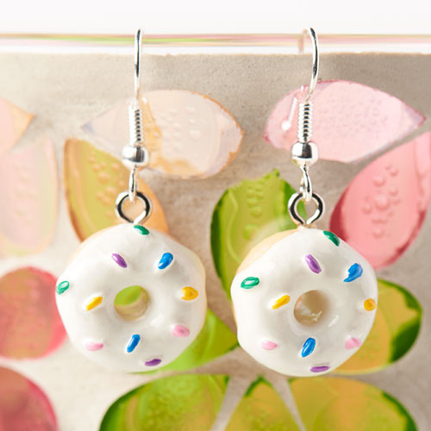
Love sweets? Make these earrings with donut resin charms. YUM!
Items used: A012460, A008998

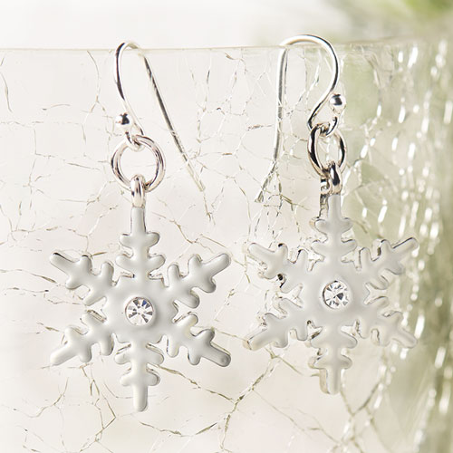
Celebrate the love of winter and fluffy snow with this pair of snowflake earrings.
Items used: FTEA0003, A011284

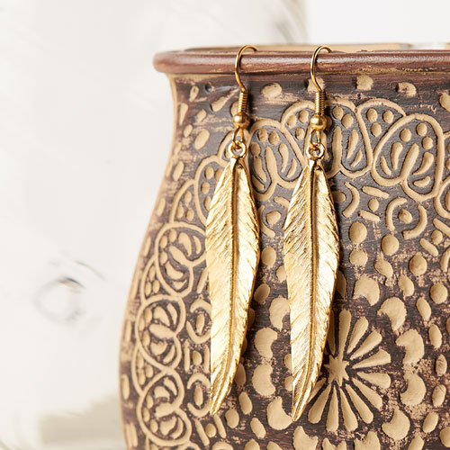
Embrace your wild side with gold feather earrings.
Items used: Z015964, A014108

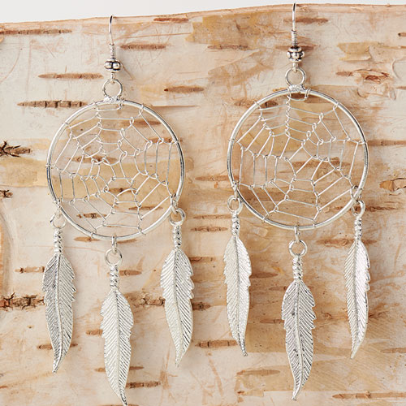
Or even channel good dreams and positive vibes with these dreamcatcher charm earrings.

